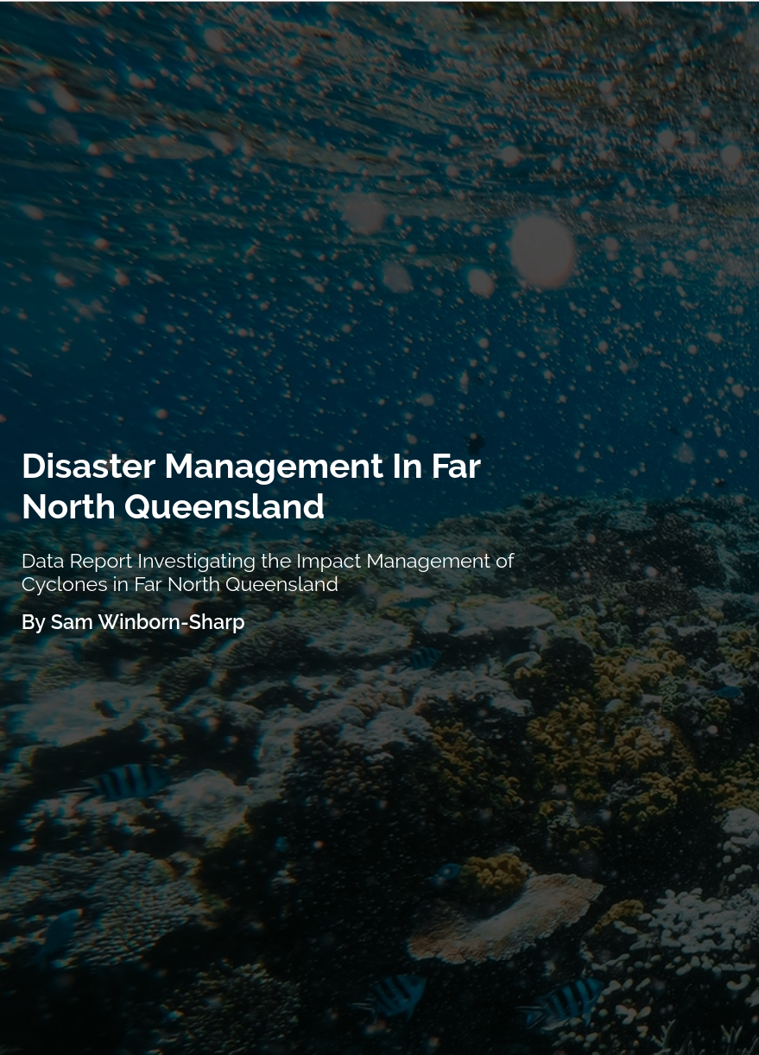

Table of Contents

**1. Introduction** **2**

**3.0 Data analysis** **3**

**3.1 Population density and settlement patterns** **3**

3.2 Topographic features 4

3.3 Level of economic development 5

3.4 Use of technologies in responding to natural hazards 6

**4.0 Impacts affecting disaster management** **8**

4.2 Social 8

4.3 Economic 9

4.4 Environmental 10

**5.0 Proposed action for disaster management in Far North Queensland** **10**

**6.0 Conclusion** **13**

**Bibliography** **14**

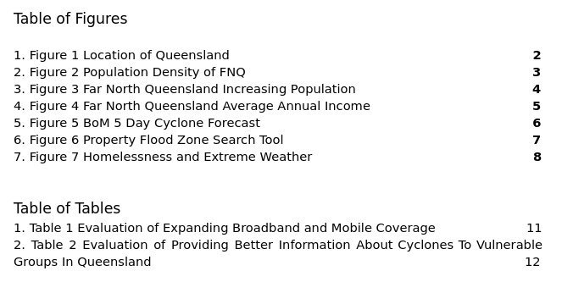

# 

# 1. Introduction

Far North Queensland (FNQ) is located in the northeastern part of Australia with the tropical Coral Sea and Pacific Oceans on its coastline (See Figure 1). FNQ is the most cyclone prone region in the country. Due to frequent cyclones occuring in Queensland the area is highly susceptible to storm surge. In 2011, Category 5 Cyclone ‘Yasi’ made landfall with wind gusts up to 285 km/hr. In the town of Cardwell the storm surge almost reached a level of 7m, the surge relocated boats inland and caused major damage to the Bruce Highway. Australia’s cyclones are most likely to occur between the months of November and April (McCormack, 2011).

Australia is one of the most economically developed countries in the world with an average GDP per capita of $52,988 (ABS, Census 2015). The Australian Government agency ‘The Bureau of Meteorology’ provides Australians with high-tech resources allowing for proper preparation for cyclones, thus reducing their impact. The State Government has worked on improving building standards and regulations (Build, 2019) to ensure the safety of residents.

It is proposed Queensland needs to implement further disaster management strategies to accommodate for people suffering from poverty and homelessness in order to reduce the impact of tropical cyclones.

*Figure 1 Location of Queensland (Source : Google Maps)*

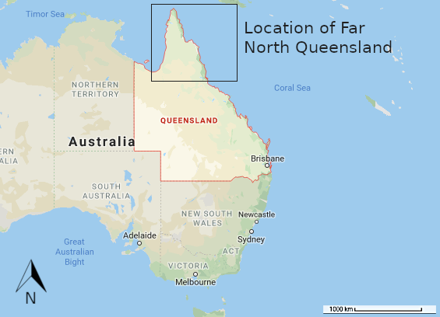

2.0 Methodology

All statistics and resources for this report have been sourced from credible and up to date sources including the Australian Bureau of Statistics, Bureau of Meteorology, Griffith University and other credible sources. The data gathered aims to provide current economic and social conditions in Queensland in order to determine how tropical cyclones have an impact on the area. Data transformations were completed to communicate data visually and clearly for the purpose of comparison and inferencing.

# 3.0 Data analysis

# **3.1 Population density and settlement patterns**

It is estimated that over 88% of Far North Queensland residents live near or on on the eastern coast (ABS Census, 2016), as illustrated in Figure 2. FNQ has a population of over 275,673 people, most of which are located in Cairns. FNQ’s population density is 0.01 persons per hectare and has a growing population with an estimated growth rate of over 1.1% p.a (see Figure 3). The impact of tropical cyclones is far greater to residents living in coastal areas as they are susceptible to storm surge. The storm surge after cyclone Yasi in 2011 had reached over 9m high in Townsville, relocating and destroying houses. (Griffith University, 2011) If the trend shown in Figure 3 continues to increase the impact of tropical cyclones will become greater, affecting a greater number of people.

*Figure 2 Population Density of FNQ (Source : Queensland Government Statistician's Office, 2017)*

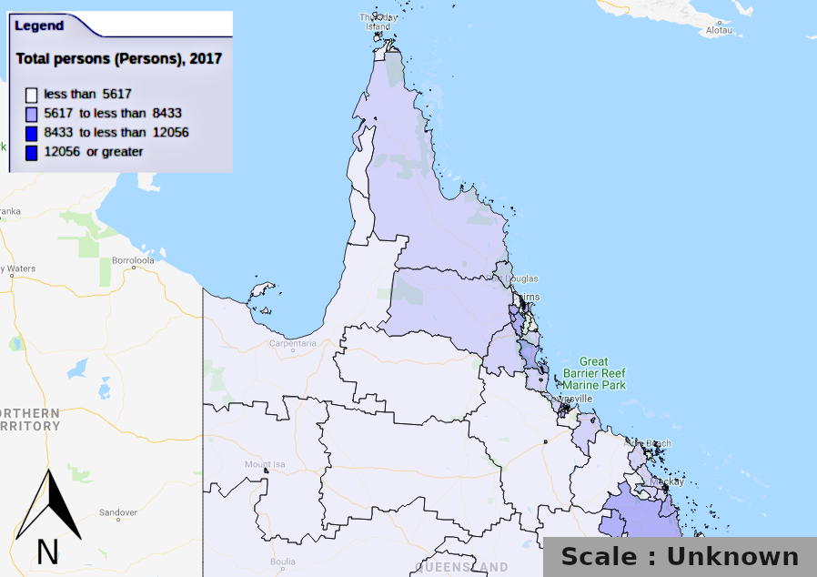

## 

Figure 3 Far North Queensland Increasing Population (Source : IdCommunity, 2017)

## 

## 

## 

## 

## **3.2Topographic features**

Due to Queensland's geographic position the surrounding ocean temperatures can reach between 24 and 33 degrees celsius in the summer. These warm temperatures massively increase the likelihood of a tropical cyclone developing. According to Coral Coe (2018), Coral reefs can naturally protect coastal areas from tropical cyclones by reducing the impact of storm surge. Dr. Michael Cuttler, from The University of Western Australia states,“ Reefs can effectively protect shorelines because of their ability to cause waves to break offshore, thus limiting the energy impacting the coastline.” With this information it can be inferred that the effect of tropical cyclones can be reduced somewhat in Queensland providing the Great Barrier Reef is in an optimal condition. Furthermore, the Great Dividing Range runs north to south between 10-100 km inland, protecting inland communities from the impacts of cyclones.

## 

## **3.3 Level of economic development**

Queensland is the third most economically developed state in Australia, making up 19.5% of the nations annual GDP (Department of Foreign Affairs and Trade, 2009). Health Care and Social Assistance is the largest employer in FNQ, generating over 17,978 local jobs in 2017. Queensland is reliant on natural resources, agriculture and tourism as its main source of income. It is estimated that in 2017 Cyclone Debbie caused $270 million in damage to cane and other crops as well as severe property damage. FNQ residents have an average income of $52 988 (USD) p.a (see Figure 4), with an estimated 71.6% homes in the area having access to the internet (IdCommunity, 2016). This means that the majority of residents have access to the news reports, weather alerts and other services that publish developing disasters awareness campaigns, however 29.4% of residents cannot rely on technology for this purpose.

Figure 4 Far North Queensland Average Annual Income (USD) (Source : ABS, Census 2015, Accessed 13-08-19)

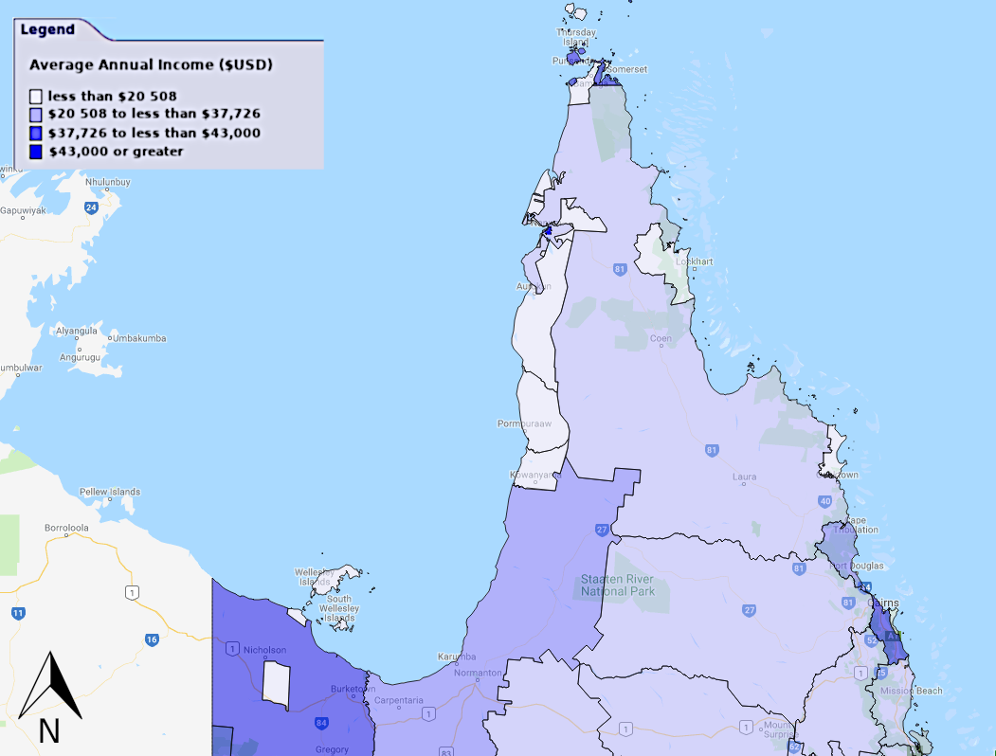

## **3.4 Use of technologies in responding to natural hazards**

Far North Queensland residents have an abundance of information to guide them through preparing for and managing the impacts after a disaster occurs. All Australians have access to the Australian Bureau of Meteorology (BoM) website which gives users an easy to understand ‘5-day Tropical Cyclone Forecast’ for their local area (See Figure 5). BoM users also have access to advanced online charting tools to see weather patterns and forecasted disasters in advance. Residents can sign up for severe weather SMS warnings with their local council for extra precaution in order to prepare early. The Council provides locals with evacuation route maps and online tools to shows users flood zones and the nearest evacuation routes (See Figure 6 and 6.5).

*Figure 5 BoM 5 Day Cyclone Forecast (Source : AU* Bureau of Meteorology*, Accessed 03-08-19, Snapshot of : http://www.bom.gov.au/cyclone/)*

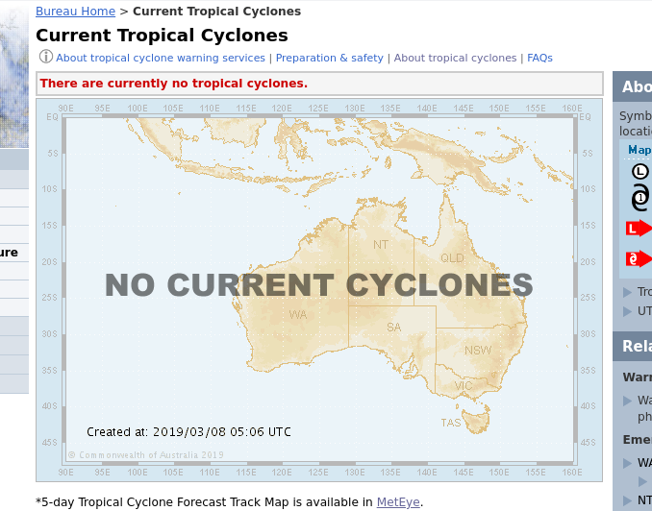

*Figure 6 Property Flood Zone Search Tool (Cairns City Council Accessed 03-08-19, Snapshot of: https://www.cairns.qld.gov.au/natural-disasters/tools/property-search)*

# 

# 

# 

# 

# 

# 

*Figure 6.5 Snap of Evacuation Flooding Routes Cairns (Snapshot of: https://www.cairns.qld.gov.au/__data/assets/pdf_file/0012/20019/6037-01-301.pdf)*

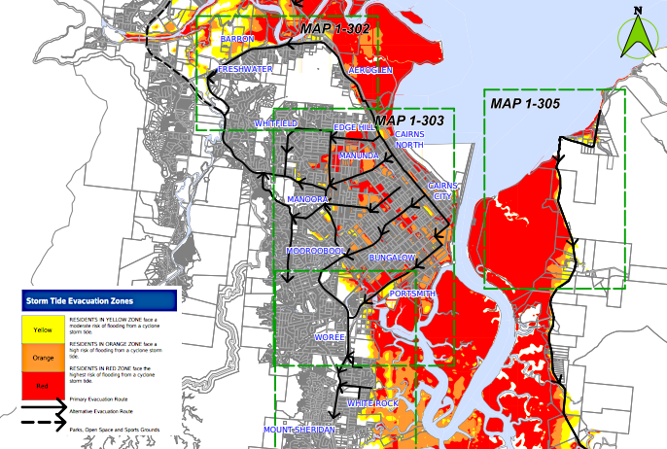

# **4.0 Impacts affecting disaster management**

Effective disaster management techniques should consider social, economic and environmental factors. The triple bottom line analysis technique can reveal the impacts these factors have on FNQ before and after disasters occur.

**4.1 Political**

The 2017 tropical cyclone Debbie was one of the strongest tropical cyclones to occur in Australian history, killing 14 people and and causing severe infrastructural damage estimated at $2.67 billion (USD) in costs. According to the Australian Broadcasting Corporation it is believed that Queensland had applied for $220 million in Natural Disaster Relief and Recovery Arrangements with the Federal Government required to transact half of the payment. The Federal Government had accused Queensland of “unfairly applying for infrastructure funding for which it was not eligible”. The Commonwealth announced that the Federal Government would offer a $29 million funding aid unless sufficient proof of damage could be shown. This amount is not even 30% of the needed financial aid required by Queensland to recover from the damage. It is clear that in the future Queensland and other regions cannot rely on Government intervention to aid in the recovery process.

## **4.2 Social**

Queensland is the 3rd most homeless state in Australia and holds over 20,000 homeless people (Australian Bureau of Statistics, 2017). It is believed that almost a third of homeless people have suffered directly from extreme weather conditions, worsening their situation. According to ‘The Conversation’ 39% of surveyed homeless people in Australia have reported damage or loss of shelter as a results of extreme weather events and 37% reported experienced development and worsening of mental health conditions (See figure 7). The report also goes on to explain that 50% of the surveyed people didn’t receive any information about extreme weather prior to the disaster occurring and 45% were unaware of what to do in such a situation. In terms of Queensland homelessness this would results in over 10,000 people clueless of what to do and where to go when a cyclone occurs.

*Figure 7 Homelessness and Extreme Weather (The Conversation, Karen McIntyre)*

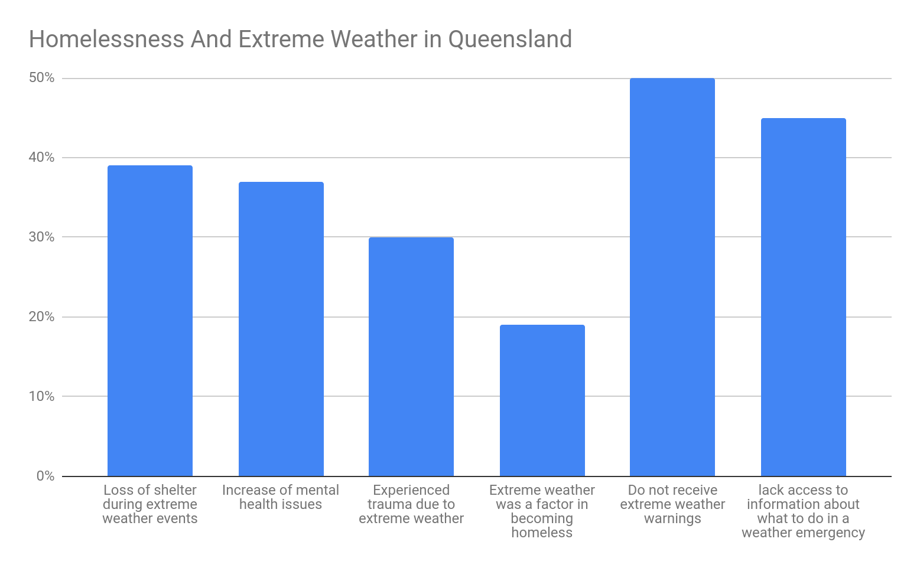

## 

## **4.3 Economic**

Queensland is an economically stable region in Australia with many residents having a moderate to high annual income, allowing them to utilise services such as internet and television weather warnings and alerts. According to The Australian Broadcasting Corporation, Queenslanders living in rural locations have poor broadband and telephone coverage. Farmers in particular rely on these services to make informed decisions to help them regulate their business. With poor coverage many farmers simply can’t access tools that provide crucial weather warnings. Therefore, without these warnings crop and livestock can be displaced and damaged due to cyclonic events and storm surge. In 2011 tropical cyclones Yasi hit Far North Queensland causing widespread damage to many crops across FNQ. This of course massively inflated crop prices in local stores. According to The Daily Telegraph, damage after cyclone Yasi causes banana prices to reach an all time high of $15 per kilo, thats over 197% more expensive than the average per kilo price today. Figure 8 provided by Telstra shows their 4G network coverage in Queensland. The coloured regions on the map indicate locations with coverage. It is clear that in central Far North Queensland and many positions on the coast there is little to no 4G Telstra coverage at all.

*Figure 8 Lack of 4G Coverage In Queensland (Source : Telstra Coverage Map, 2019)*

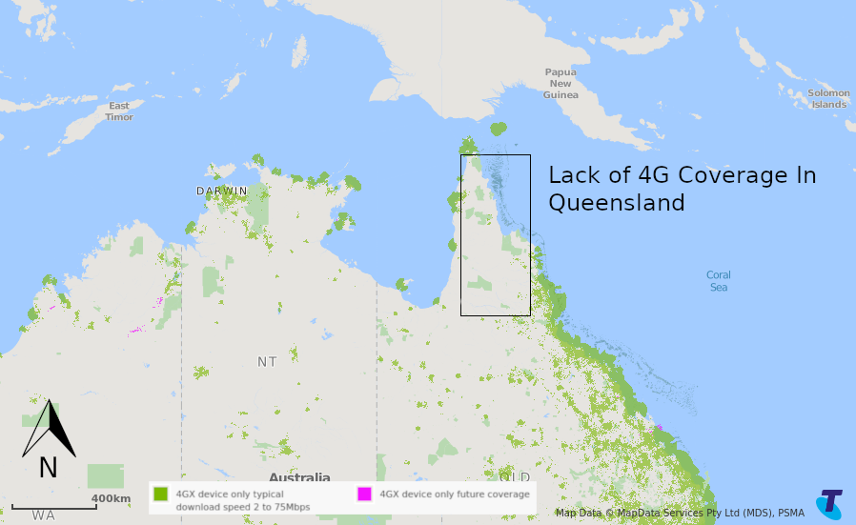

## **4.4 Environmental**

The Great Barrier Reef and other natural ecosystems are resilient to storm surge, tropical cyclonic events and other natural disasters. However with changes in climate the frequency of these events have increase reducing the time for the ecosystems to recover. With the frequency of cyclones increasing along with the effects of coral bleaching coral reefs such as the Great Barrier Reef are much more susceptible to coral damage and ecosystem imbalances causing reduced numbers in species. According to Great Barrier Reef Marine Park Authority, Tropical cyclone Hamish in 2009 affected more than 50 per cent of the coral reefs in the Queensland. Damage to the coral reef then makes coastal areas more susceptible to storm surge as the natural barrier no longer exists.

# **5.0 Proposed action for disaster management in Far North Queensland**

The majority of Queenslanders are not severly affected by tropical cyclones as building regulations & standards have improved. However for people facing poverty, those living in rural areas and tourists have little information about what to do when a cyclone occurs. Therefore it is these group that are vulnerable during cyclones.

**Option 1 : Expand Broadband and Mobile Coverage In Rural Areas**

For farmers and people living in rural areas broadband and mobile coverage is poor. However these people rely on these technologies to get informed weather warnings and alerts. In order to overcome this problem more technological infrastructure is needed in these rural areas of Far North Queensland. Table 1 shows an evaluation of this solution using the triple bottom line analysis.

Table 1 Evaluation of Expanding Broadband and Mobile Coverage In Queensland for Disaster Management

|  |  |  |
| --- | --- | --- |
| Social | Economic | Environmental |
| + Expands communication and provides rural residents reliable and up to date news  + Help develop social connections between affected communities.  + integration of energy sources provide better responses.  - may replace current news outlets | + create hundreds of jobs opportunities for locals with knowledge of the technology during installation or for maintenance.  + Improves values of homes as they now have internet coverage.  - Infrastructure will be expensive to install and maintain.  + May be able to use a renewable energy source to reduce costs. | + prior warnings through this technology allow locals to protect property, infrastructure and help wildlife before such events occur.  + Allows for faster cleanup as councils can receive cleanup request via a more accessible technology  - Technology may output damaging radiation to wildlife.  - Technology often relies on electricity, if generated by fossil fuels this will have a damaging effect on the environment.  - Removal of forests and for infrastructure installation. |

**Option 2 :** Provide better information to tourists and people living in **poverty**.

Shelters, evacuation routes and emergency services are available to everyone when required in a cyclone. However these services and information is not widely known and therefore tourists and people in poverty are unnecessarily affected by the tropical cyclones and storm surges. This too can be solved by providing clear and extensive information to all. This can be achieved by placing multi-linguistic information billboards in cities, providing hotels with an information pack for travelers or a universal mobile phone app with that provides location based safety information.

Table 2 Evaluation of Providing Better Information About Cyclones To Vulnerable Groups In Queensland

|  |  |  |
| --- | --- | --- |
| Social | Economic | Environmental |
| + Gives tourists and people living in poverty peace of mind as they know what to do and how to seek help when cyclonic events occur.  + Provides assistance to vulnerable residents  - All languages need to be able to cover a wide array of tourists. | + Is relatively inexpensive to implement  + Boosts tourism as tourists have peace of mind knowing what do in such events  + A phone mobile application is relatively inexpensive to host and can be integrated into hotels easily and cheaply. | + Can achieved through using non-harmful environmental materials and resources. |

# 

# **6.0 Conclusion**

Far North Queensland is located in the northeastern part of Australia, due to its geographic positioning the surrounding ocean temperatures can reach between 24 and 33 degrees celsius in the summer. These conditions make coastal areas of Far North Queensland highly susceptible to damage from both tropical cyclones and storm surge. Queensland sustains a level high of economic development therefore for the majority of residents with high paying jobs the effects of cyclones are not severe as buildings have high regulation standards. However to the less economically developed portion of society cyclones and storm surges can damage sheltering locations and can also increase mental health conditions due to the traumatic stress of these events. Farmers and rural living residents all rely on broadband services to receive weather warnings and alerts. Due to a lack of information in rural areas of Far North Queensland these information services are not accessible to everyone.

Services such as Rosies and the Salvation Army provide assistance to those in need but clearly this is not enough. Further Information needs to be available to everyone in all languages. Tourists also face similar problems as little disaster management information is provided in foreign languages. This results in confusion amongst tourists and would have an impact on the tourism industry due to tourists being frightened and clueless of what to do in cyclonic event. Although technological infrastructure is widely needed across areas of rural Far North Queensland this is highly expensive to implement. Therefore implementing affordable but reliable multi linguistic information through billboards and hotels allows for the homeless and tourists to know services are provided to them if a cyclone were to occur. This will have beneficial economical effects on the tourism industry as well as reducing casualty levels in poorer communities.

# 

# 

# Bibliography

1. *2016 Census QuickStats: Aurukun (S) 2016, Abs.gov.au, viewed 28 February 2019, <http://quickstats.censusdata.abs.gov.au/census_services/getproduct/census/2016/quickstat/LGA30250?opendocument>.*
2. *Agius, K 2017, ‘Turnbull happy for cyclone selfies but not disaster funding, Qld lashes out’, ABC News, 14 July, Australian Broadcasting Corporation, viewed 17 March 2019, <https://www.abc.net.au/news/2017-07-15/cyclone-debbie-queensland-federal-government-disaster-payments/8711310>.*
3. *Cash In Hand Weekend Jobs In Cairns QLD | CareerOne 2019, Careerone.com.au, viewed 5 March 2019, <https://www.careerone.com.au/cash-in-hand-weekend-jobs/in-cairns-qld>*
4. *Department of Foreign Affairs and Trade. Commonwealth of Australia. November 2009. <https://web.archive.org/web/20091117091207/http://www.dfat.gov.au/geo/fs/qld.pdf>*
5. *Cyclone code requirements for walls 2019, BUILD, viewed 28 February 2019, <http://www.build.com.au/cyclone-code-requirements-walls>.*
6. *Estimated Resident Population (ERP) | Far North Queensland Regional Organisation of Councils | Community profile 2017, Id.com.au, viewed 5 March 2019, <https://profile.id.com.au/fnqroc/population-estimate>.*
7. *Far North Queensland 2010, Far North Queensland, viewed 5 March 2019, <https://www.google.com/maps/place/North+Queensland,+QLD/@-17.084367,133.3044655,5.24z/data=!4m5!3m4!1s0x6a19e84e9b2de537:0xe0def38f0ee9fe2a!8m2!3d-20.7722295!4d144.7851531>.*
8. *Internet connection | Far North Queensland Regional Organisation of Councils | Community profile 2016, Id.com.au, viewed 5 March 2019, <https://profile.id.com.au/fnqroc/internet-connection>.*
9. *McCormack, M 2011, Griffith University - Storm Surge: Know Your Risk in Queensland!, Griffith.edu.au, viewed 28 February 2019, <https://www.griffith.edu.au/__data/assets/pdf_file/0016/107314/CEMDSS-Storm-Surge-Community-Info-Sheet_Final.pdf>.*
10. *Queensland Thematic Maps (Queensland Government Statistician’s Office, Queensland Treasury) 2019, Qld.gov.au, Queensland Treasury, Queensland, viewed 5 March 2019, <https://statistics.qgso.qld.gov.au/qld-thematic-maps>.*
11. *Richard Harold Greenwood & Saunders, K 2019, Queensland | Flag, Facts, Maps, & Points of Interest, Encyclopædia Britannica, viewed 28 February 2019, <https://www.britannica.com/place/Queensland-state-Australia>.*
12. *Storm tide property search 2017, Cairns Regional Council, viewed 8 March 2019, <https://www.cairns.qld.gov.au/natural-disasters/tools/property-search>.*
13. *Tropical Cyclones 2019, Bom.gov.au, corporateName=Bureau of Meteorology, viewed 8 March 2019, <http://www.bom.gov.au/cyclone/>.*
14. *Telstra - Our Coverage 2014, Telstra.com.au, viewed 19 March 2019, <https://www.telstra.com.au/coverage-networks/our-coverage#content_accordion>.*
15. *Klein, N. (2011). Banana drama over: prices crash. [online] Dailytelegraph.com.au. Available at: https://www.dailytelegraph.com.au/news/national/prices-of-bananas-fall-after-crops-recover-from-cyclone-yasi/news-story/a426ad5906a2d0e86f72578c0629f2d8 [Accessed 27 Mar. 2019].*